**Diabetes Prediction Using Machine Learning**

Minor project report submitted in partial fulfilment of the requirement for the degree of Bachelor of Technology

in

**Computer Science and Engineering**

By

Vaibhav Sharma(191545)

Ansh Jaiswal(191541)

**UNDER THE SUPERVISON OF**

Dr. Pradeep Kumar Gupta



Department of Computer Science & Engineering and Information Technology

**Jaypee University of Information Technology , Waknaghat, 173234, Himachal Pradesh, INDIA**

**TABLE OF CONTENT**

|  |  |
| --- | --- |
| **Title** | **Page No.** |
| **Declaration** |  |
| **Certificate** |  |
| **Acknowledgement** |  |
| **Abstract** |  |
| **Chapter-1 (Introduction)** |  |
| **Chapter-2 (Feasibility Study, Requirements Analysis and Design** |  |
| **Chapter-3 (Implementation)** |  |
| **Chapter-4 (Results)** |  |
| **References** |  |

**DECLARATION**

I hereby declare that, this project has been done by me under the supervision of **Dr. Pradeep Kumar Gupta, Affiliation,** Jaypee University of Information Technology. I also declare that neither this project nor any part of this project has been submitted elsewhere for award of any degree or diploma.

**Supervised by:**

**Dr. Pradeep Kumar Gupta**

Designation

Department of Computer Science & Engineering and Information Technology

Jaypee University of Information Technology

**Submitted by:**

Vaibhav Sharma(191545)

Ansh Jaiswal(191541)

Computer Science & Engineering Department

Jaypee University of Information Technology

**CERTIFICATE**

This is to certify that the work which is being presented in the project report titled **“Railway Route Optimization System”** in partial fulfilment of the requirements for the award of the degree of B.Tech in Computer Science And Engineering and submitted to the Department of Computer Science And Engineering, Jaypee University of Information Technology, Waknaghat is an authentic record of work carried out by “Vaibhav Sharma(191545) and Ansh Jaiswal(191541).” during the period from January 2022 to May 2022 under the supervision of Dr.Pradeep Kumar Gupta, Department of Computer Science and Engineering, Jaypee University of Information Technology, Waknaghat.

Vaibhav Sharma(191545)

Ansh Jaiswal(191541)

The above statement made is correct to the best of my knowledge.

(Dr. Pradeep Kumar Gupta)

Designation

Computer Science & Engineering and Information Technology

Jaypee University of Information Technology, Waknaghat,

**AKCNOWLEDGEMENT**

Firstly, I express my heartiest thanks and gratefulness to almighty God for His divine blessing makes us possible to complete the project work successfully.

I really grateful and wish my profound my indebtedness to Supervisor **Dr** Pradeep Kumar Gupta **Designation**, Department of CSE Jaypee University of Information Technology, Wakhnaghat. Deep Knowledge & keen interest of our supervisor in the mentioned field to carry out this project. His endless patience, scholarly guidance, continual encouragement, constant and energetic supervision, constructive criticism, valuable advice, reading many inferior drafts and correcting them at all stage have made it possible to complete this project.

I would like to express my heartiest gratitude to **Dr** Pradeep Kumar Gupta**,** Department of CSE, for his kind help to finish my project.

I would also generously welcome each one of those individuals who have helped me straight forwardly or in a roundabout way in making this project a win. In this unique situation, I might want to thank the various staff individuals, both educating and non-instructing, which have developed their convenient help and facilitated my undertaking.

Finally, I must acknowledge with due respect the constant support and patients of my parents.

Vaibhav Sharma(191545)

Ansh Jaiswal(191541)

**ABSTRACT**

Our website has various kinds of information that helps regarding booking of tickets via

railways .

Users will be able to search the train availability ,the exact fare ,the arrival and

departuretime of the train and they can also book the ticket by using the debit ,credit

or master card and after booking the ticket if the user want to cancel it then they can

easily do it also.

The objective of the online railway reservation management system

Project is to design software to fully automate the process of issuing a railway ticket.

That is:-

1. To create a database of the trains

2. To search the trains it’s arrival and departure time,distance between source and

destination.

3.To check the availability of the ticket.

4. To calculate fare.

5.To book the ticket.

6.To cancel the ticket if necessary

● Railway passengers frequently need to know about their ticket reservation status,

ticket availability on a particular train or for a place, train arrival or departure details,

special trains etc.. Customer information centers at the railway stations are unable to

serve such queries at peak periods.

● The number of the reservation counters available to the passengers and customers are very

less.

● On most of the reservation systems there are long queues, so it takes a long time for

any individual to book the ticket.As now there are no call centers facilities available

to solve the queries of the passengers.

● The online railway ticket reservation system aims to develop a web application which aims

at providing trains details, trains availability, as well as the facility to book ticket in online

for customers.

● So, we thought of developing a web based application which would provide the users all

these facilities from his terminal only as well as help them in booking their tickets. The

Application was to be divided into two parts namely the user part , and the administrator

part. And each of these has their corresponding features.We decided to give the name of the

website “RAILWAY RESERVATION MANAGEMENT SYSTEM”.The online railway

ticket reservation system is developed using ASP.NET with C# as the backend in the .NET

Framework.

Railway reservation management system is a online ticket booking website, which is capable

of booking ticket and serach the train availavility . This website is mainly created to fulfil the

following requirements, it comprises of the following properties:-

● A central database that will store all information.

● An online website that will provide real- time information about the availability of

tickets their prices .

● Every registered user is able to view his booking id that has been made in his/her

name.

● Every registered user can change his password any time he wants to change.

**Chapter 01:INTRODUCTION**

* **Introduction**

The project entitled “Railway Route Optimization system“ is developed as a part of the sixth semester minor project, for the fulfillment of the requirement for the BTech course.

Our website has various kinds of information that helps regarding booking of tickets via railways .

Users will be able to search the train availability ,the exact fare ,the arrival and departuretime of the train and they can also book the ticket by using the debit ,creditnor master card, through the fastest route and after booking the ticket if the user want to cancel it then they can

easily do it also.

* **Objective**

The objective of the online railway route optimization system

Project is to design software to fully automate the process of issuing a railway ticket and find the fastest train routes.

That is:-

1. To create a database of the trains

2. To search the trains it’s arrival and departure time,distance between source and

destination.

3.To check the availability of the ticket.

4. To calculate the time taken from each route and give the shortest one.

5. To calculate fare.

6.To book the ticket.

7.To cancel the ticket if necessary

* **Motivation**

● Railway passengers frequently need to know about their ticket reservation status, ticket availability on a particular train or for a place, train arrival or departure details, special trains etc.. Customer information centers at the railway stations are unable to

serve such queries at peak periods.

● The number of the reservation counters available to the passengers and customers are very less.

● On most of the reservation systems there are long queues, so it takes a long time for any individual to book the ticket.As now there are no call centers facilities available to solve the queries of the passengers.

● The online railway ticket reservation system aims to develop a web application which aims

at providing trains details, trains availability, as well as the facility to book ticket in online for customers.

● So, we thought of developing a web based application which would provide the users all these facilities from his terminal only as well as help them in booking their tickets. The Application was to be divided into two parts namely the user part , and the administrator part. The online railway ticket reservation system is developed using ASP.NET with C# as the backend in the .NET Framework.

* **Language Used**

Server side

1. Programming language: PHP 5.6.31

2. Web Server: Apache 2.4.27

3. Database: SQL 5.7.19

Client side

1. Programming language: JAVASCRIPT, HTML, CS

2. OS: windows7/8/10

3. MYSQL server

PHP

PHP is a server-side scripting language designed primarily for web development but

also used as a general programming language PHP code may be embedded into

HTML or HTML5 markup or it can be used in combination with various web

template systems, web content management systems, and web frameworks. PHP code

is usually processed by a PHP interpreter implemented as a module in the web server.

The web server software combines the results of the interpreted and executed PHP

code, which may be any type of data, including images, with the generated webpage.

WEB SERVER: APACHE

Apache is the most widely used web server software. Developed and maintained by

Apache Software Foundation, Apache is open-source software available for free. It

runs on 67% of all web servers in the world. It is fast, reliable, and secure. It can be

highly customized to meet the needs of many different environments by using

extensions and modules. Most WordPress hosting providers use Apache as their web

server software. However, WordPress can run on other web server software as well.

HTML

HTML is an acronym that stands for HyperText Markup Language.

HyperText: HyperText simply means "Text within Text". A text has a link within it, is

a hypertext. Every time you click on a word that brings you to a new webpage, you

have clicked on a hypertext.

Markup language: A markup language is a programming language that is used to

make text more interactive and dynamic. It can turn a text into images, tables, links,

etc. An HTML document is made of many HTML tags and each HTML tag contains

different content

.

JAVASCRIPT

Javascript is a dynamic computer programming language. It is lightweight and most

commonly used as a part of web pages, whose implementations allow client-side

script to interact with the user and make dynamic pages. It is an interpreted

* **Technical Requirements ( Hardware)**

● A desktop or laptop with a proper internet connection

● 2 500GB or 60GB of the hard disk

● 3.4GB 2GB of the RAM

● 4 Windows 7 or 8 or 10 Operating system

* **Deliverables/Outcomes**

Our system can successfully give information on any train,find trains running between two stations ,book tickets and cancel tickets.This system could be used for official trainbooking.However several other features could be added like booking meals on trains etc. Also payment gateways have to be implemented to make sure the transactions happen securely.

**Chapter 02:Feasibility Study, Requirements Analysis and Design**

**2.1 Feasibility Study**

**2.1.1 Problem Definition**

Railway Route Optimization System is a product to serve to users who are tourists. The Main purpose of the project is to let the end users or passengers to know the shortest path to reach the destination with in short period and with amount as minimum as possible and as early as possible when more than one Railways route is to there to reach the destination.

**2.1.2 Problem Analysis**

**2.1.3 Solution**

The system will allow users to search for trains between any two stations on a given date.and to book the ticket on that particular date.

The Railways Route Optimization has 4 Modules

•Stations

•Trains

•Route

•Search

**2.2 Requirements**

**2.2.1 Functional Requirements**

The required software is used for ordering food online. The system should satisfy the following requirements:

1. Logging into the system

2. Signup option

3. View Menu Details

4. Order Option

6. View User Orders

7. Logout option

**2.2.2 Non-Functional Requirements**

All of the application data is stored in an Oracle database, and therefore an Oracle Database must also be installed on the host computer. As with Apache2, this software is freely available and can be installed and run under most operating systems. The server hardware can be any computer capable of running both the web and database servers and handling the expected traffic. For a small scale restaurant that is not expecting to see much web traffic, an average personal computer may be appropriate.

Once the site starts generating more hits, though, it will likely be necessary to upgrade to a dedicated host to ensure proper performance. The exact cut-offs will need to be determined through a more thorough stress testing of the system.

**2.3 E-R Diagram / Data-Flow Diagram (DFD)**

* Point 2.1 includes the literature survey done.

An entity–relationship model describes inter-related things of interest in a specific domain of knowledge. An ER model is composed of entity types and specifies relationships that can exist between instances of those entity types.

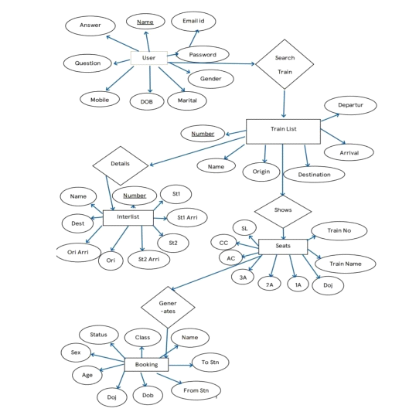

This ER Diagram gives a brief idea about the relations existing between the tables and

tells about the primary and the foreign keys being used in this Database.

**Chapter 03: IMPLEMENTATION**

**3.1 Date Set Used in the Minor Project**

Database and database technology has a major impact on the growing use of computers. It is fair to say that databases play a critical role in almost all areas where computers are used, including business, electronic commerce, engineering, medicine, genetics, law, education, and library science.

The word database is so commonly used that we must begin by defining what the database is. Our initial definition is quite general. A database is a collection of related data. By data, we mean known facts that can be recorded and that have implicit meaning. For example, consider the names, telephone numbers, and addresses of the people you know. You may

have recorded this data in an indexed address book or you may have stored it on a hard drive, using personal computers and software such as Microsoft excel. This collection of related data with an implicit meaning is a database.

The preceding definition of a database is quite general, for example, we may consider the collection of words that make up this page of text to be related data and hence to constitute a database. However, the common use of the term database is usually more restricted. A database has the following properties: A database represents some aspect of the real world, sometimes called the mini world or the universe of discourse. The changes to the mini world are reflected in the database. A database is a logically coherent collection of data with some inherent meaning. A random assortment of data cannot correctly be referred to as a database. A database is designed, built and populated with data for a specific purpose. It has an

intended group of users and some preconceived applications in which these users are interested. In other words, a database has some source from which data is derived, some degree of interaction with events in the real world, and an audience that is actively interested in its contents. The end-users of the database may perform business transactions (for example a

customer buys a camera) or events may happen that may cause the information in the database to change. In order for a database to be accurate and reliable at all times, it must be a true reflection of the mini world that it represents; therefore changes must be reflected in the database as soon as possible .A database can be of any size and complexity. A database may be generated and maintained manually or computerized. For example, a library card catalog is a database that may be created and maintained manually. A computerized database may be created and maintained either by a group of application programs written specifically for that task or by a

database management system. A database is a collection of data, typically describing the activities of one or more related organizations. For example, a university database might contain information about the following

Entities such as students, faculty, courses, and classrooms.

Relationships between entities, such as student’s enrolment in courses, faculty teaching courses, and the use of rooms for courses.

**3.2 Date Set Features**

**3.2.1 Types of Data Set**

**The Three-Schema Architecture**

The goal of the three-schema architecture illustrated in the figure is to separate the user application from the physical database. In this architecture, schemas can be defined at the following three levels:

● The internal level has an internal schema, which describes the physical storage structure of the database. The internal schema uses a physical data model and describes the complete details of data storage and access paths for the database.

● The conceptual level has a conceptual schema, which describes the structure of the whole database for a community of users. The conceptual schema hides the details of physical storage structures and concentrates on describing entities, data types, relationships, user operations, and constraints. Usually, a representational data model is used to describe the conceptual schema when a database system is implemented. This implementation conceptual schema is often based on a conceptual schema design in a high-level data model.

● The external or view level includes a number of external schemas or user views. Each external schema describes the part of a database that a particular user group is interested in and hides the rest of the database from that user group. As in the previous level, each external schema is typically implemented using a representational data model, possibly based on external schema design in a high level data model.

**3.2.2 Number of Attributes, fields, description of the data set**

**3.3 Design of Problem Statement**

Generally, railway reservation systems will not give any result whenever the user searches train between any two station which do not have any direct trains between them, and hence user will have no clue for how to reach the destination.

However, we have overcome this problem. Our system on these types of searches will give a path from source to destination which are connected by some railway routes on which the user can search trains for reaching the destination.

**3.4 Algorithm / Pseudo code of the Project Problem**

This result is based on well famous **Dijkstra’s Algorithm**.

Dijkstra's algorithm allows us to find the shortest path between any two vertices of a graph.

It differs from the minimum spanning tree because the shortest distance between two vertices might not include all the vertices of the graph

**2.5 Flow graph of the Minor Project Problem**

Dijkstra's Algorithm works on the basis that any subpath B -> D of the shortest path A -> D between vertices A and D is also the shortest path between vertices B and D.

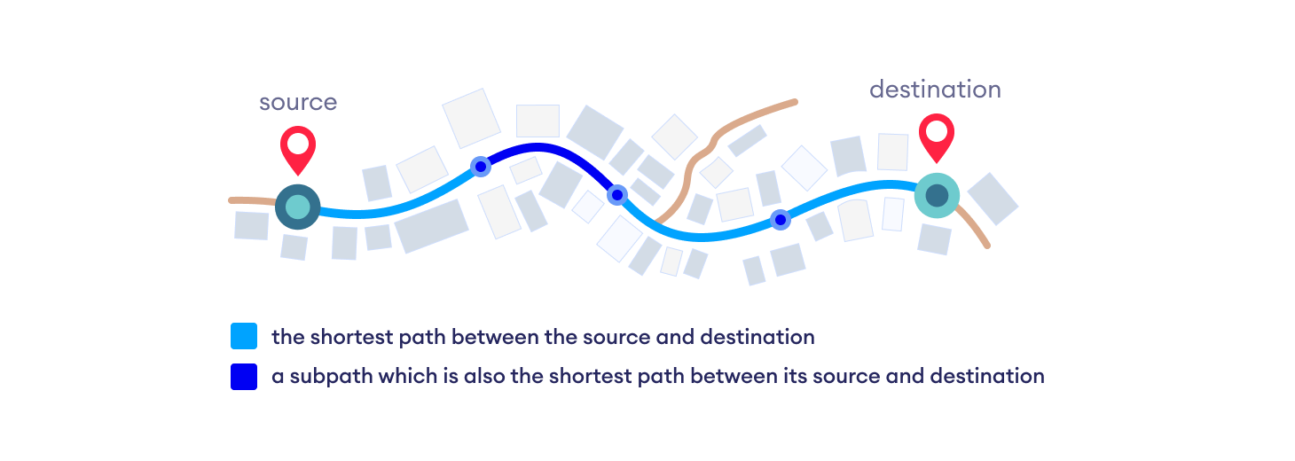

Djikstra used this property in the opposite direction i.e we overestimate the distance of each vertex from the starting vertex. Then we visit each node and its neighbors to find the shortest subpath to those neighbors.

The algorithm uses a greedy approach in the sense that we find the next best solution hoping that the end result is the best solution for the whole problem.

**3.6 Screen shots of the various stages of the Project**

**1.Home Page**

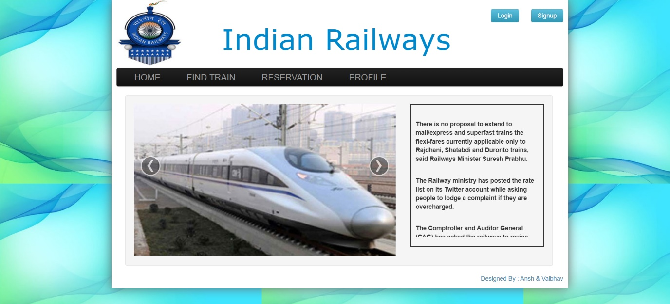

**2. Find Train Page**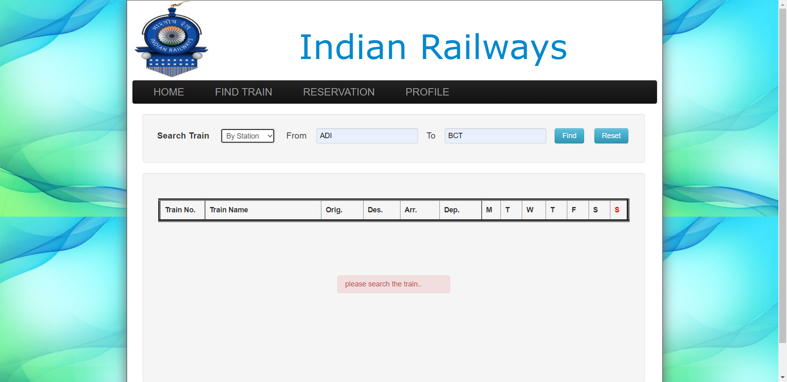

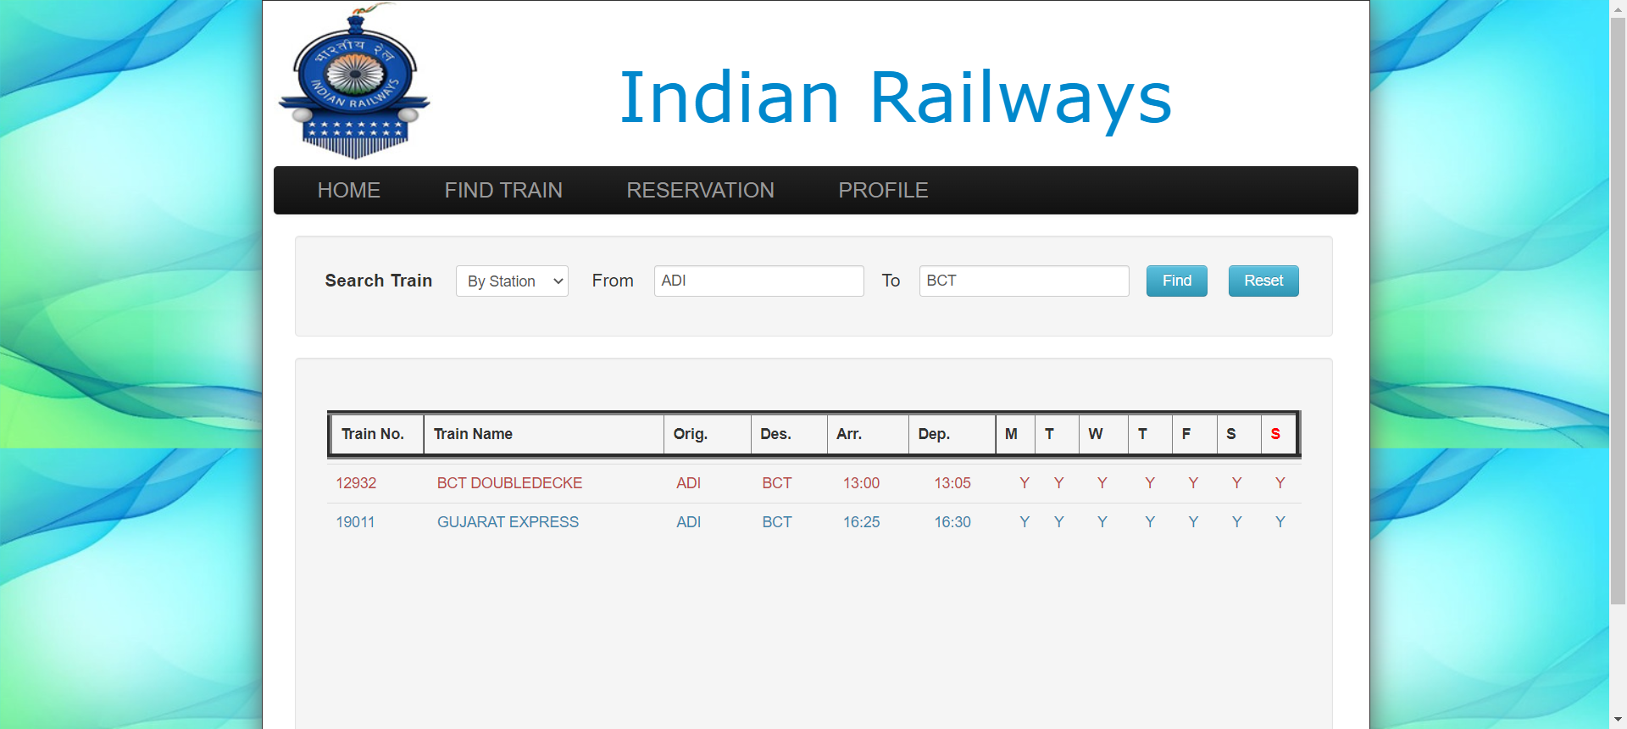

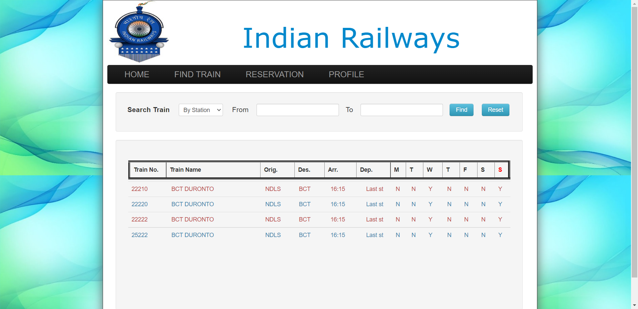

**3. Reservation Page**

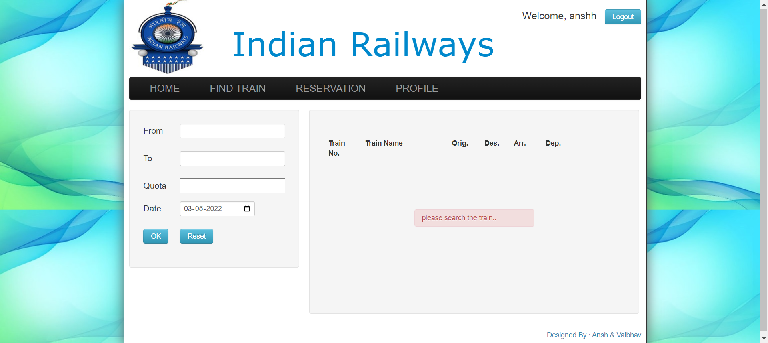

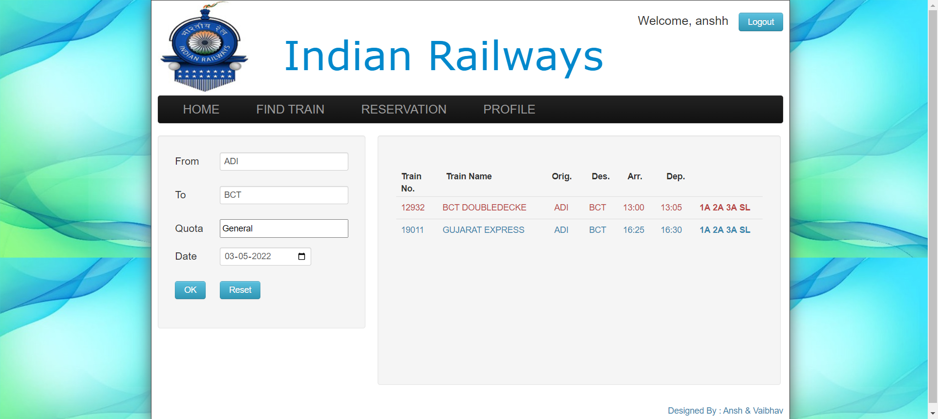

**4. Tickets Page**

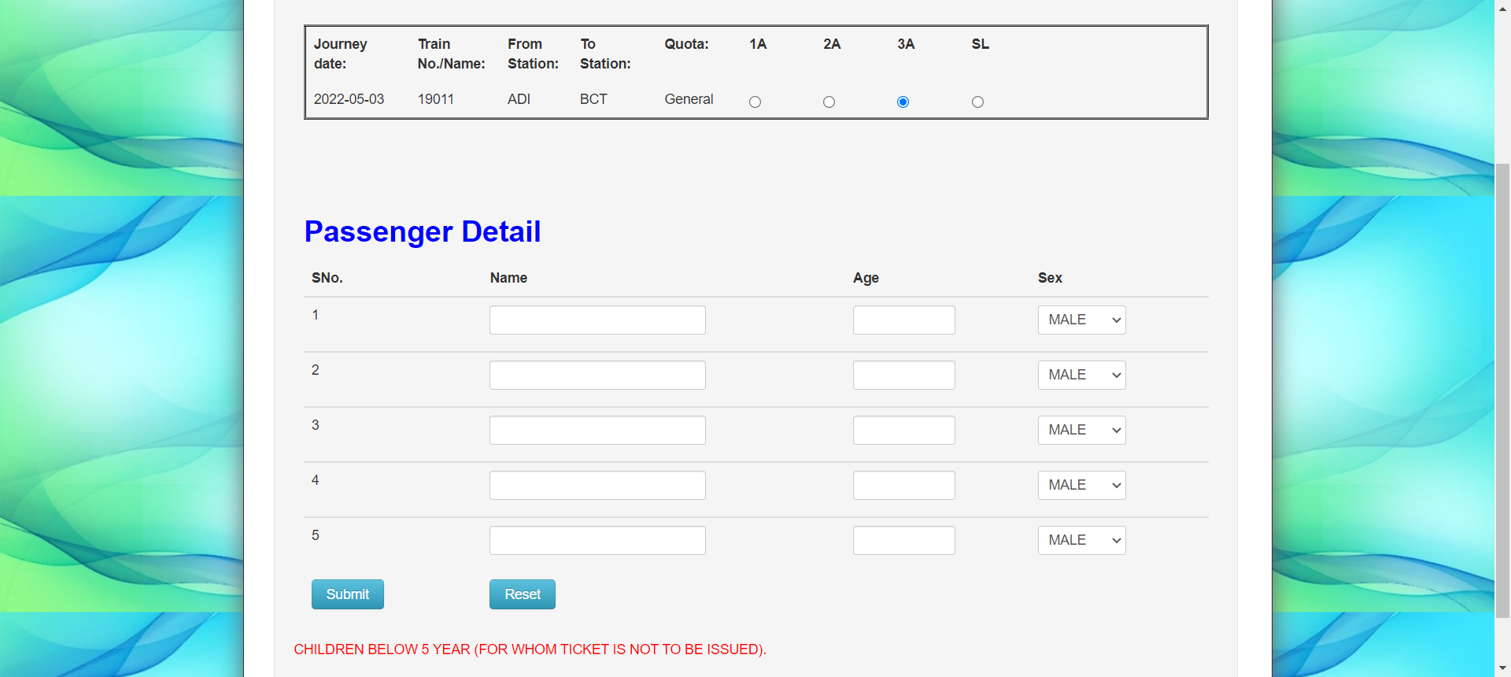

**5. Sign-Up Page**

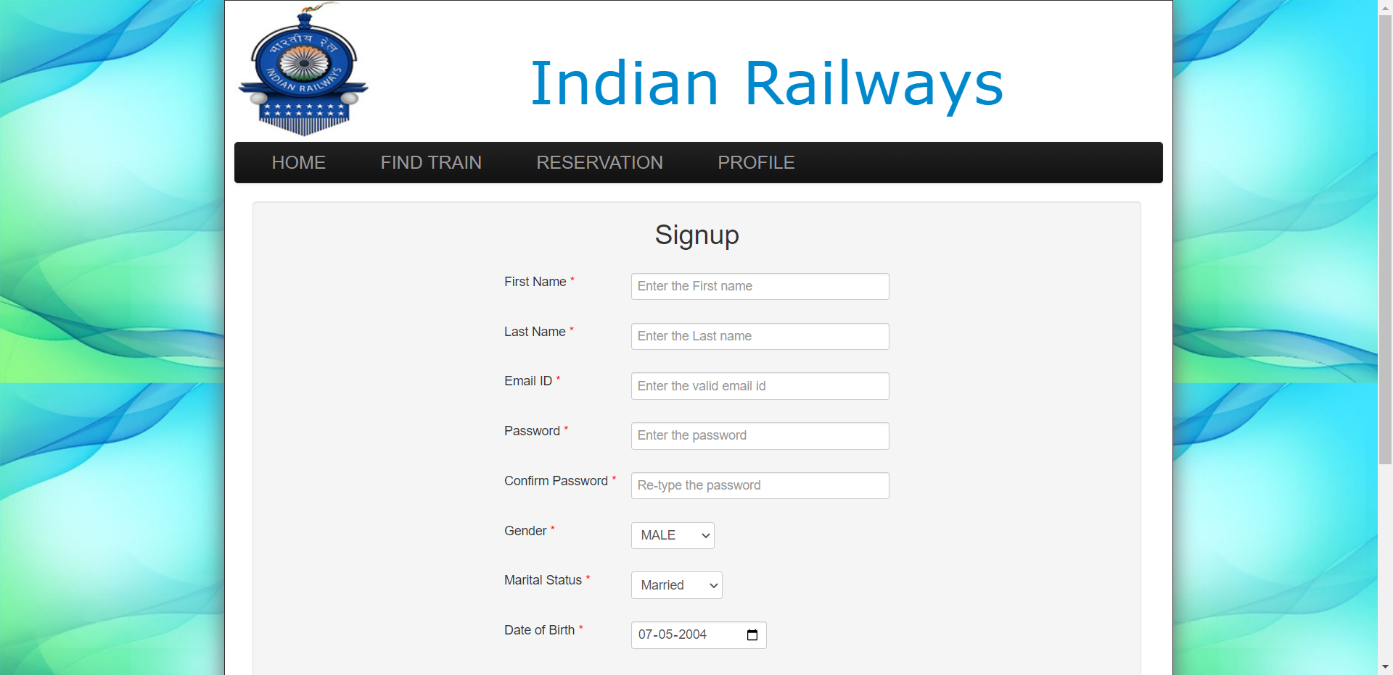

**6. Login and Profile Page**

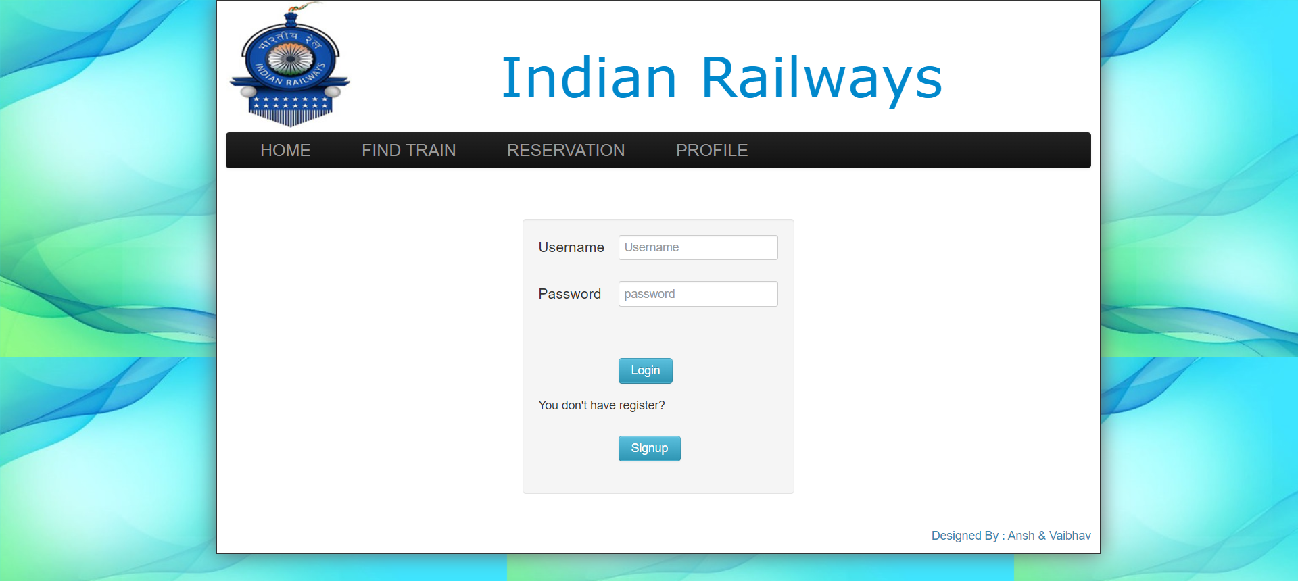

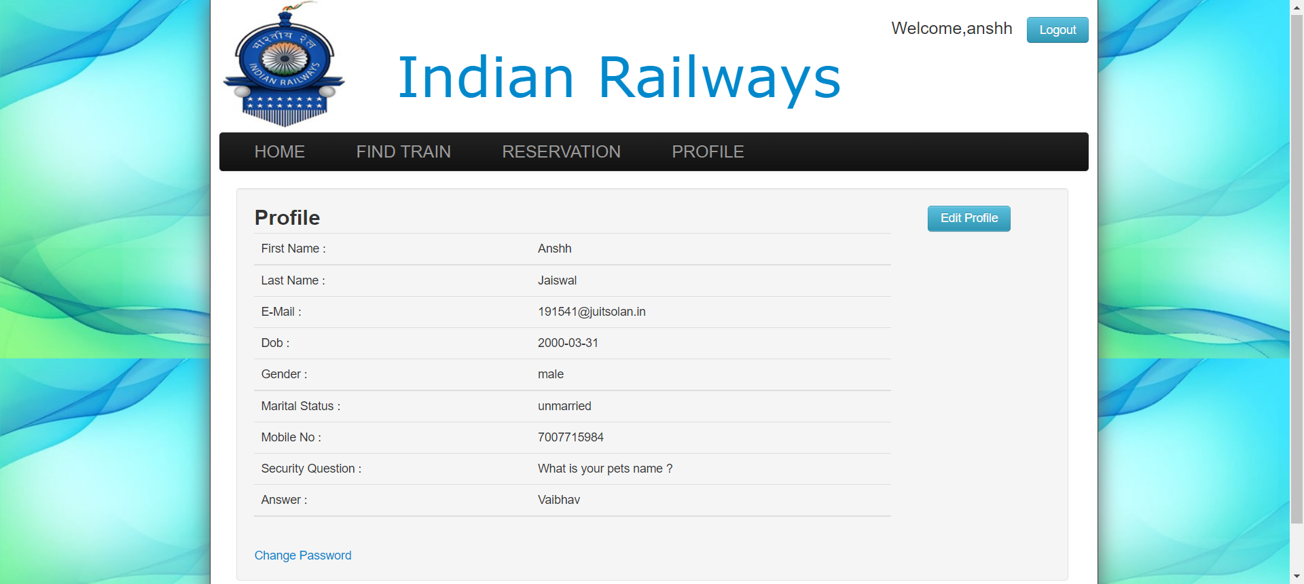

**7. Edit Profile and Change Password Page**

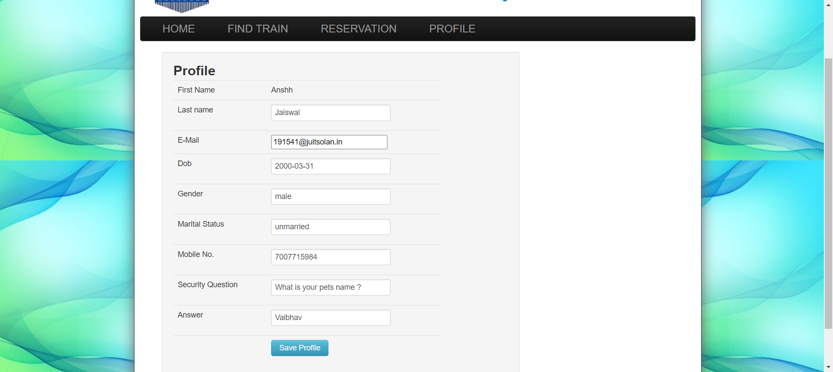

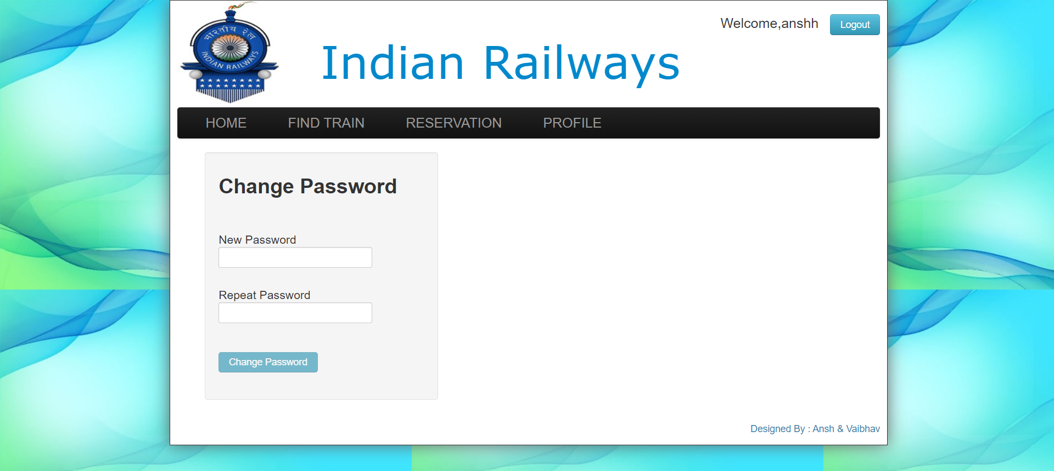

**Chapter 04: RESULTS**

**4.1 Discussion on the Results Achieved**

Generally, railway reservation systems will not give any result whenever the user searches train between any two station which do not have any direct trains between them, and hence user will have no clue for how to reach the destination.

However, we have overcome this problem. Our system on these types of searches will give a path from source to destination which are connected by some railway routes on which the user can search trains for reaching the destination.

**4.2 Application of the Minor Project**

The Main purpose of the project is to let the end users or passengers to know the shortest path to reach the destination with in short period and with amount as minimum as possible and as early as possible when more than one Railways route is to there to reach the destination.

**4.3 Limitation of the Minor Project**

The anticipated time frame for us was not enough for us but we tried to design a realistic schedule in order to complete the study in time.

Our study met the problem of inadequate founds for the research in terms of expenses such as transport, internet, printing. However, we tried to borrow from friends, relatives to accomplish the study

**4.4 Future Work**

● We can even further make it private and secured by implementing Log-

in IDs and encrypting them with passwords.

● We can give away this software for more number of people and

organizations to conduct a Beta Testing and based upon the results we

can just make those changes and be assured of the application

developed.

● We can make it more space and resource efficient so that this

application consumes lesser RAM and ROM and battery power (if

available).

**References**

**All references must be in any standard style format, like IEEE/APA/etc.**

Additional Guidelines:-

* There is no page limit as such but above mentioned titles and non-titles must be part of the project report. Ideally it should be of 25 to 50 pages.
* Each report must be designed as per the format but the title of chapters, sub titles and number of chapters can be decided by the guide based on specific project.
* Each project report must have a proper Table of Content.
* Each report must have the page number starting from the chapter number 1.
* Front page of the report should not be marked with any page number.
* Declaration, Certificate and Table of Content must have numbers in roman (I, II, III….)
* All references must be written in any standard style format, like IEEE/APA/etc.
* All the references must be cited into the text at the appropriate place in the report.
* Similarity index must be less than 20%
* Margins (1.5 on left, right, top, bottom), Line spacing 1.5 (as is present in this template), Body of the running text – 12 pts. Times new roman
* Indentation of 1.27 on the first line of each paragraph.
* Other formatting styles to be considered as is present in this template.